***Programming II WS2122***

***Lab1***

***OOA and UML***

***Tennis Task***

**Use-case Diagram:**

**Class Diagram:**

**State Diagram:**

***IMDB Task***

**Use-case Diagram:**

**Class Diagram:**

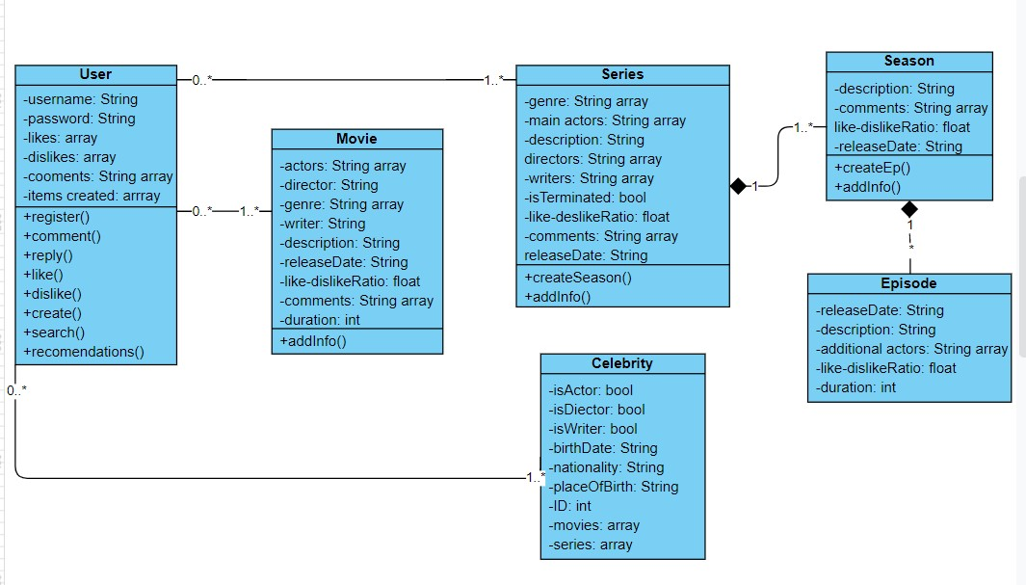

**State Diagram:**

